1. From the rat in a maze problem, explain the code

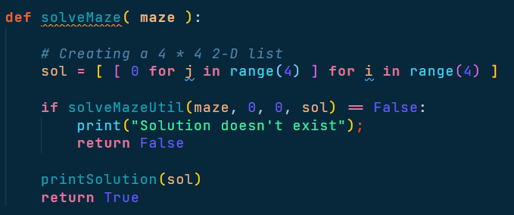

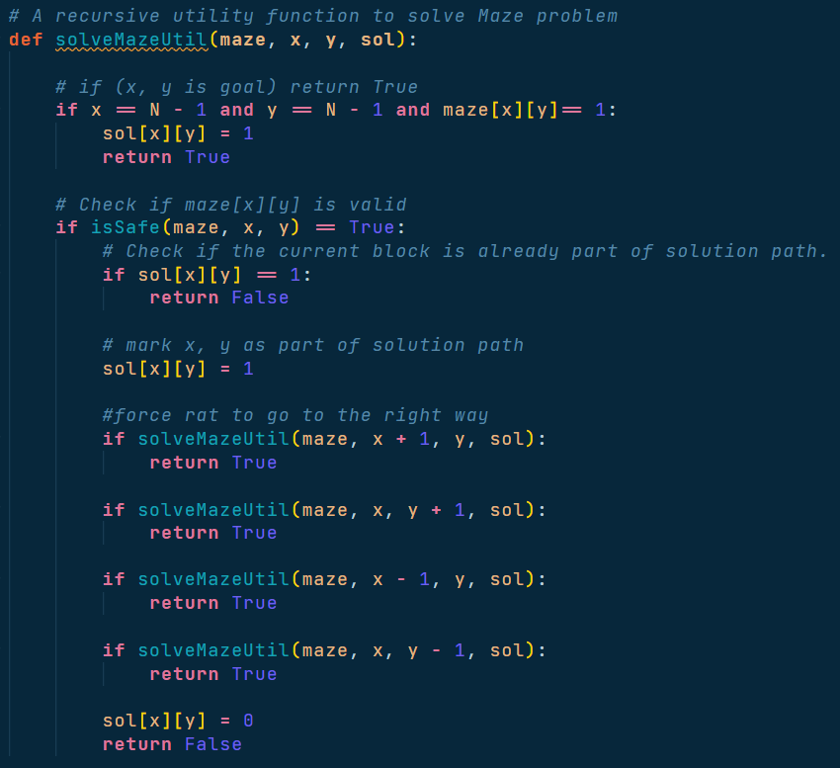This method is written for solve the solution if there no solution at the first place [matrix row 0 colum 0] there will say that “Solution doesn’t exist” otherwise it will print how the rat goes though the maze

This method is guide the rat though the maze (we will talk about the is safe next session). The method will check all direction of the path it if rat can go to the path it will force the rat to go instantly

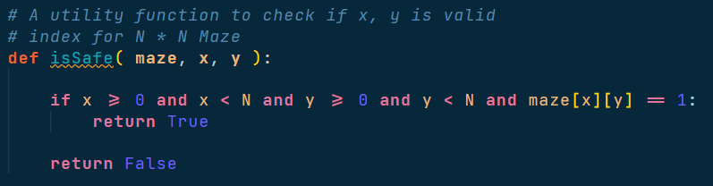

This method is checking the current path that rat will goes can go or not by checking if there are 1 (mean can go) or is it a bound of the maze or not if rat can go it will response true otherwise false

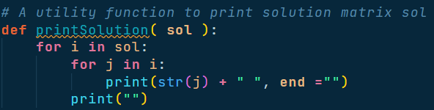

This method will call when the rat goes out of the maze or there are no way to go because of we are represented the maze as a matrix so we use 2 for loop to print a path of the maze

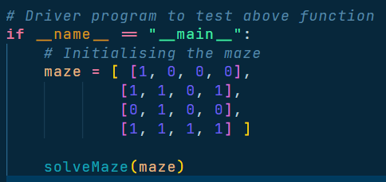

This is a driver method that will give the maze and let the rat goes

1. Show each step of code when the maze is   
   step 1

Color term:   
red: current path

Blue: path check  
green: passed path

|  |  |  |
| --- | --- | --- |
| Step | Real Maze | Rat path |
| 1 | 1 0 0 0  1 1 0 1  0 1 0 0  1 1 1 1 | 0 0 0 0  0 0 0 0  0 0 0 0  0 0 0 0 |
| 2 | 1 0 0 0  1 1 0 1  0 1 0 0  1 1 1 1 | 1 0 0 0  0 0 0 0  0 0 0 0  0 0 0 0 |
| 3 | 1 0 0 0  1 1 0 1  0 1 0 0  1 1 1 1 | 1 0 0 0  1 1 0 0  0 0 0 0  0 0 0 0 |
|  |  |  |
| 4 | 1 0 0 0  1 1 0 1  0 1 0 0  1 1 1 1 | 1 0 0 0  1 1 0 0  0 1 0 0  0 0 0 0 |
| 5 | 1 0 0 0  1 1 0 1  0 1 0 0  1 1 1 1 | 1 0 0 0  1 1 0 0  0 1 0 0  0 1 0 0 |
| 6 | 1 0 0 0  1 1 0 1  0 1 0 0  1 1 1 1 | 1 0 0 0  1 1 0 0  0 1 0 0  0 1 1 0 |
| 7 | 1 0 0 0  1 1 0 1  0 1 0 0  1 1 1 1 | 1 0 0 0  1 1 0 0  0 1 0 0  0 1 1 1 |
| 8 | 1 0 0 0  1 1 0 1  0 1 0 0  1 1 1 1 | 1 0 0 0  1 1 0 0  0 1 0 0  0 1 1 1 |

Optional   
Windows 10 education   
Visual studio code January update  
python 3.8  
code from Shiv Shankar  
  
Explain the code and visualize by Sahachan Tippimwong  
submit to Aj Algorithm